CELEBRATE BOOKS & MUSIC & RAGGEDY ANN AND ANDY
WITH
FOLKLORIST-MUSICIAN-AUTHOR
PATTY HALL

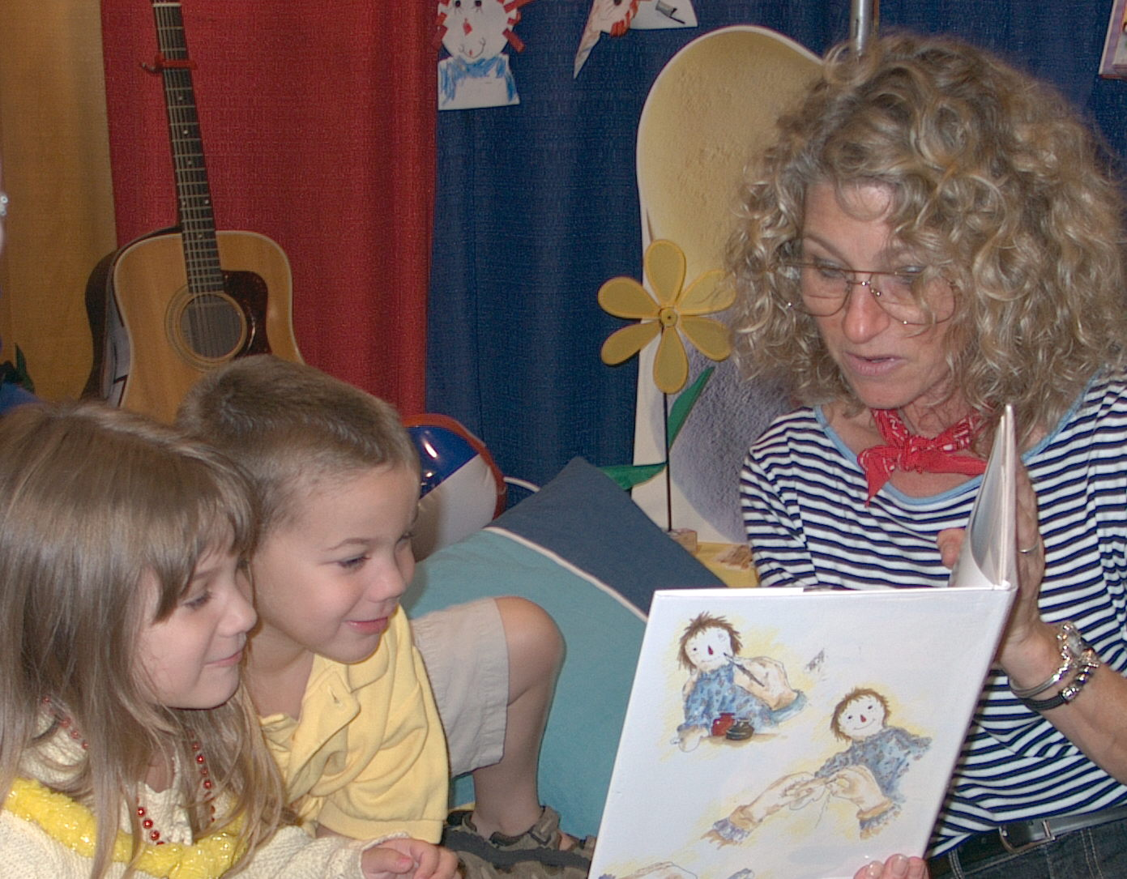
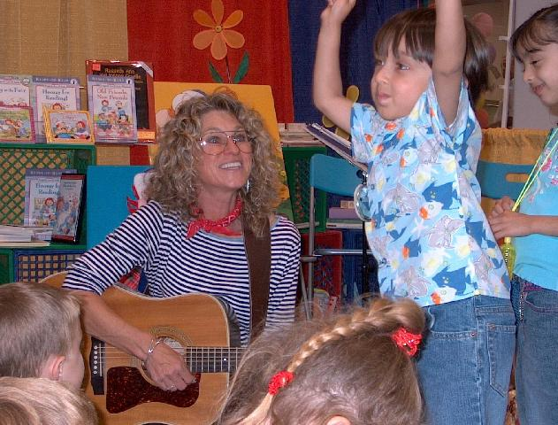

DEL MAR PUBLIC LIBRARY
1309 Camino del Mar * Del Mar, CA
(corner of 13th and Camino Del Mar)

FRIDAY, OCTOBER 8, 2004
9:00 – 10:00 AM

RAGGEDY ANN & ANDY:
A BOOK IS BORN!

Do you dream of seeing your name on the cover of a book? Have you wondered how bright ideas transform into published works? Join Patty as she takes a look at book-making and offers a glimpse inside the writer’s life. Free, but reservations required -- call 858-755-1666

WEDNESDAY, OCTOBER 13, 2004
6:30 – 7:15 PM

Jumpin’ Up!™ Songs
Down-Home Music for Modern Kids

Tune up your voices and get ready to have some fun with folk music, as Patty presents lively, kid-friendly songs on guitar and banjo and shares instruments from around the world. Free.

Patty’s books about Raggedy Ann & Andy will be for sale following each program.

VISIT PATTY AT HER WEBSITE

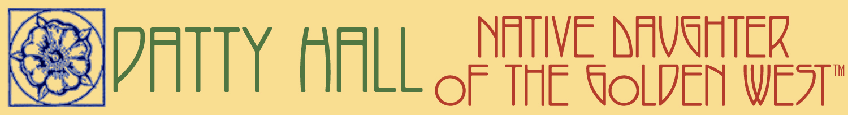
www.pattyhall.com

